### Part h - Build an AutoML Forecasting Model with Vertex AI

This document has screenshots of the following steps -

* Create a managed dataset
* Import data from a Google Cloud Storage Bucket
* Update the column metadata for appropriate use with AutoML
* Train a model using options such as a budget and optimization objective
* Make online batch predictions

The dataset in this codelab will be [Iowa Liquor Sales dataset](https://console.cloud.google.com/marketplace/product/iowa-department-of-commerce/iowa-liquor-sales) from BigQuery Public Datasets. This dataset consists of wholesale liquor purchases in the US state of Iowa since 2012.

1. Creating a tabular dataset using vertex datasets

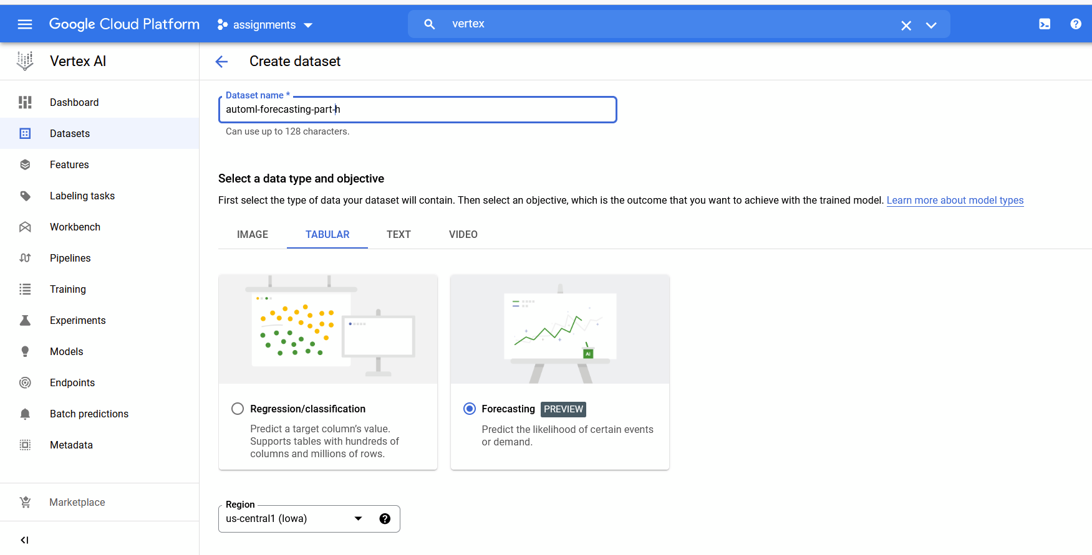

1. Adding Iowa liquor dataset from Auto ML cloud bucket

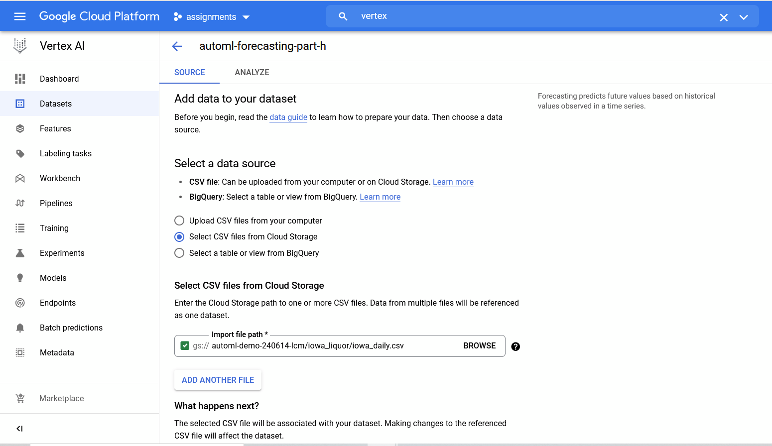

1. Adding model details for training the model

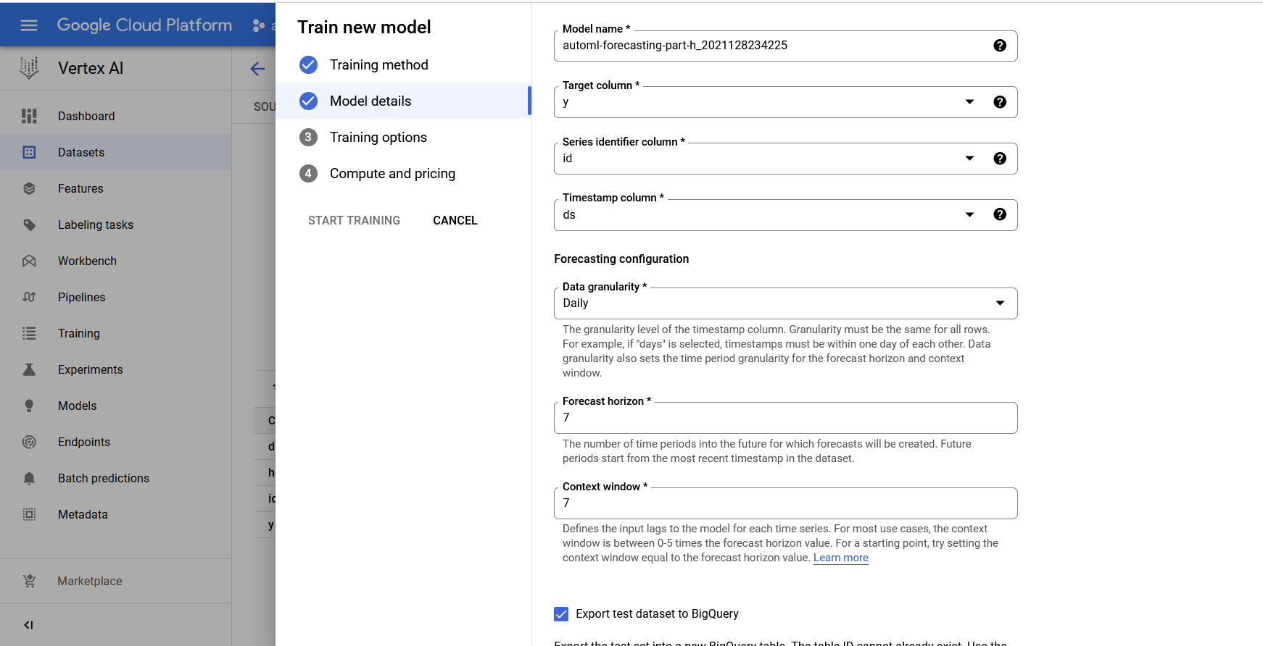

1. Customizing some more training options

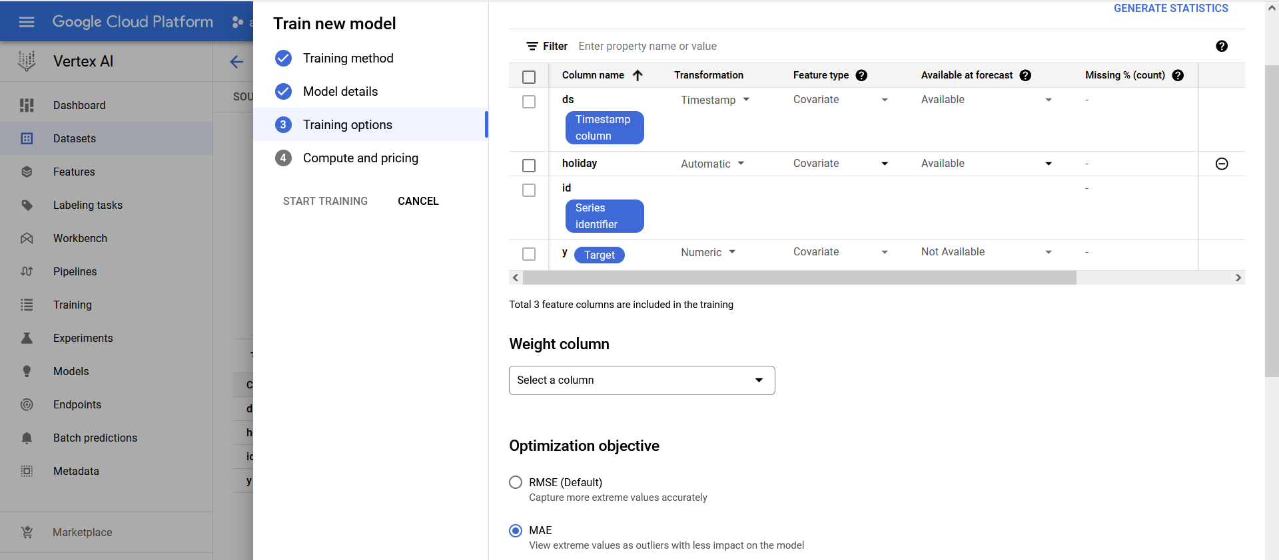

1. Training job complete and evaluation metrics of the model

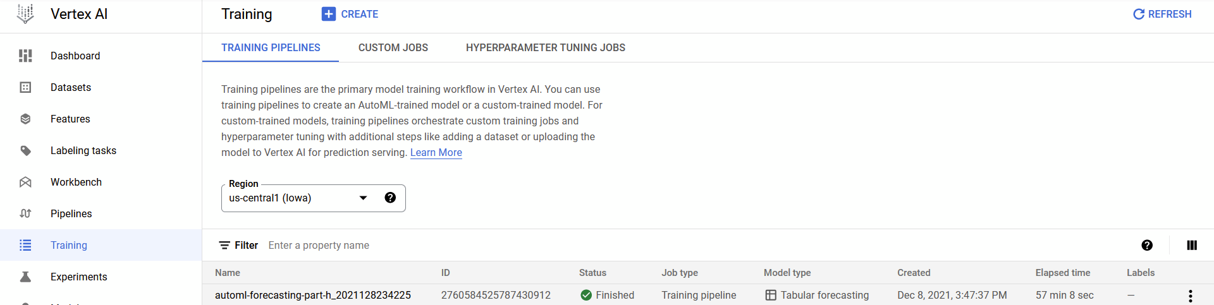

1. Review test predictions in BigQuery

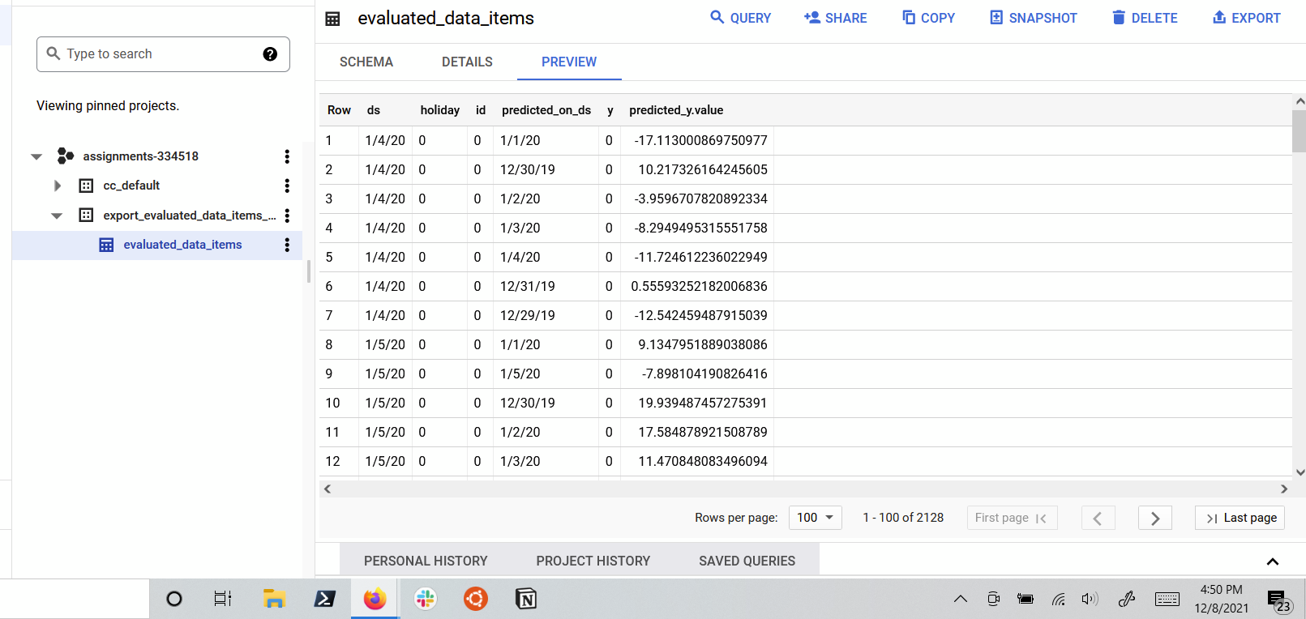

1. Running batch predictions

